Assignment -1

AMIL -Section-1

Q.1

1. **250 / 500**



1. **55 / 500**
2. **25 / 200**
3. **20 / 500**

Q.2



Q. 3 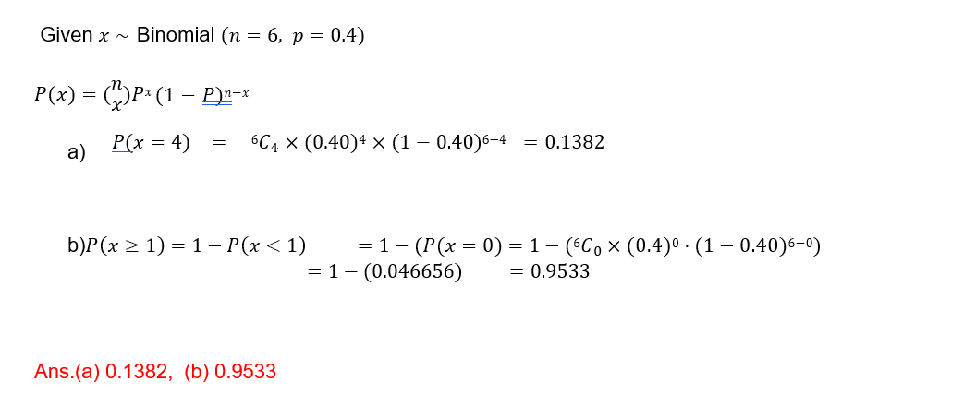



Q.4 answer 0.90

